Задание 1

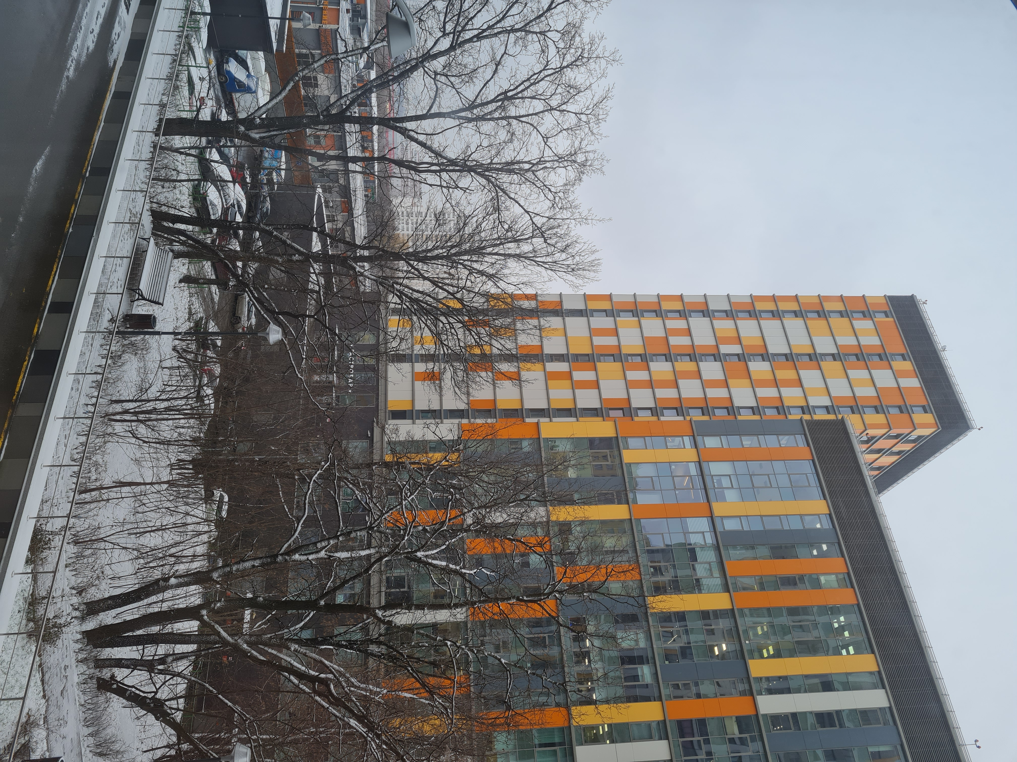

|  |  |
| --- | --- |
| **Dimension** | 4032x3024 |
| **Make** | samsung |
| **Camera Model** | SM-G780F |
| **Orientation** | Rotated 90 CW |
| **Resolution** | 72x72 inches |
| **Software Version** | G780FXXU1ATK1 |
| **Date and Time** | 2020:12:01 13:33:07 |
| **Y Cb Cr Positioning** | center of pixel array |
| **Shutter Speed** | 1/185 s |
| **Exposure Time** | 0.0054 s |
| **f-number** | ƒ1.8 |
| **Exposure Program** | Normal program |
| **ISO Speed Used** | 50 |
| **Exif Version** | 0220 |
| **Date and Time (Original)** | 2020:12:01 13:33:07 |
| **Date and Time (Digitized)** | 2020:12:01 13:33:07 |
| **Aperture Value** | 1.69 |
| **Brightness Value** | 13.11 |
| **Exposure Compensation** | 0 EV |
| **Maximum Aperture Value** | 1.69 |
| **Metering Mode** | CenterWeightedAverage |
| **Flash** | Flash did not fire |
| **Focal Length** | 5.4mm (35mm Film Focal Length Equivalent: 26mm) |
| **Color Space** | sRGB |
| **Dimension** | 4032x3024 |
| **Exposure Mode** | Auto |
| **White Balance** | Auto white balance |
| **Digital Zoom Ratio** | 1 |
| **Scene Capture Type** | Standard |
| **Image Unique ID** | X12LLND01AM |
| **GPS Latitude Ref** | N |
| **GPS Latitude** | 55.841894199722226 |
| **GPS Longitude Ref** | E |
| **GPS Longitude** | 37.3700247 |

Задание №2

Большая часть файлов в формате pdf

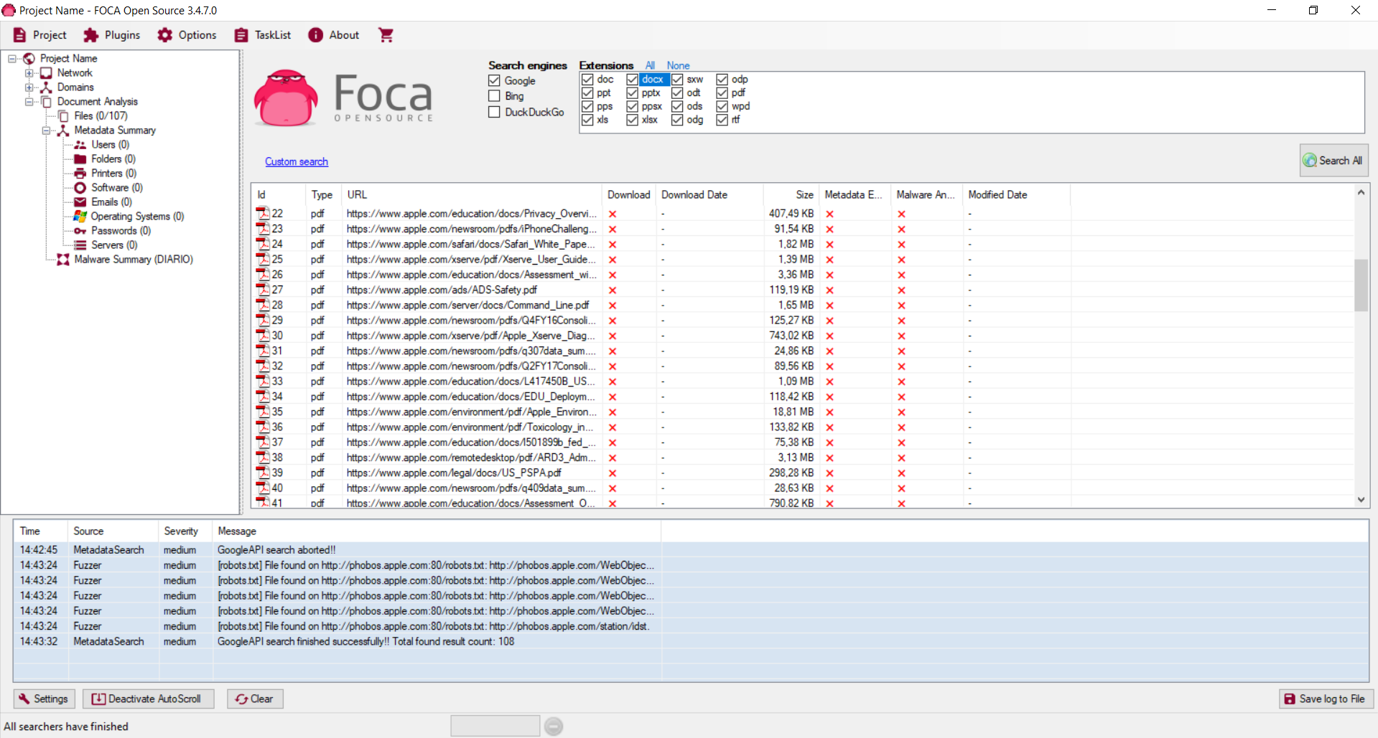

Задание №3

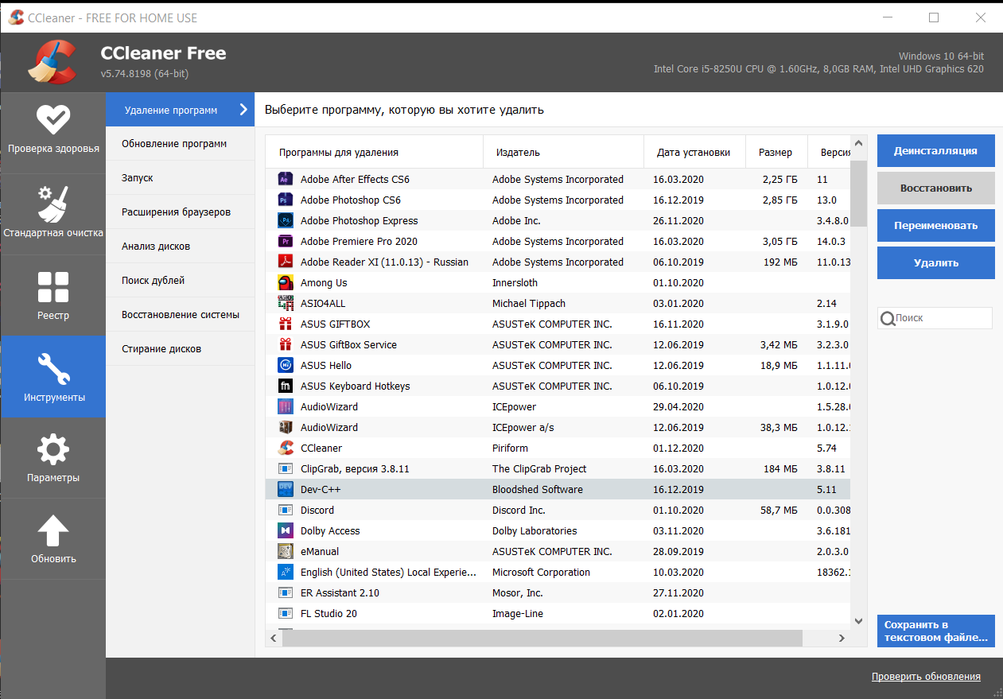

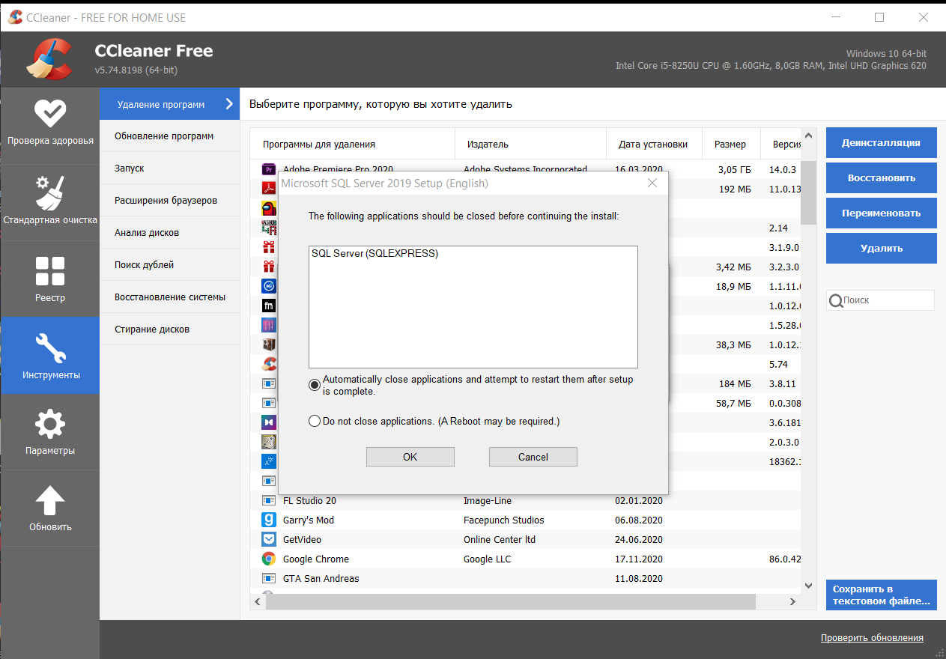

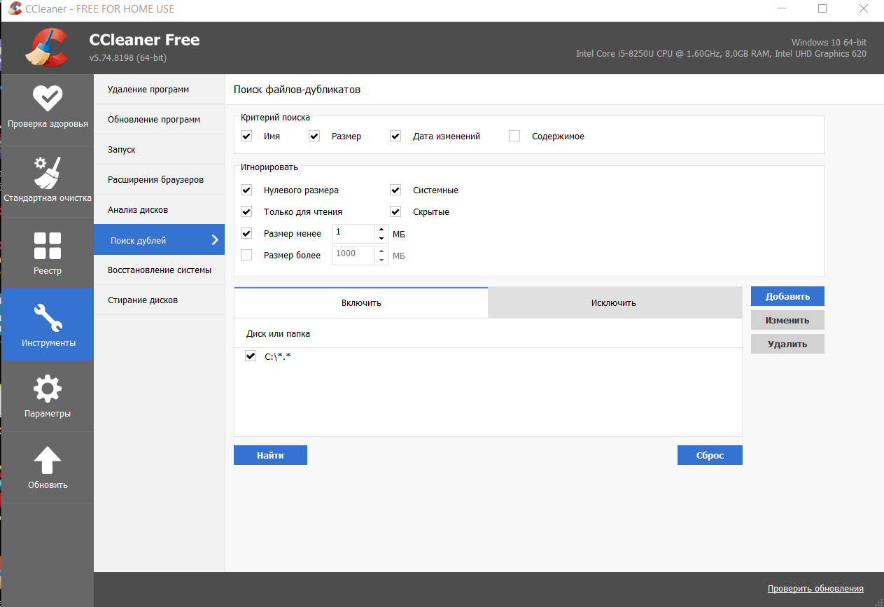





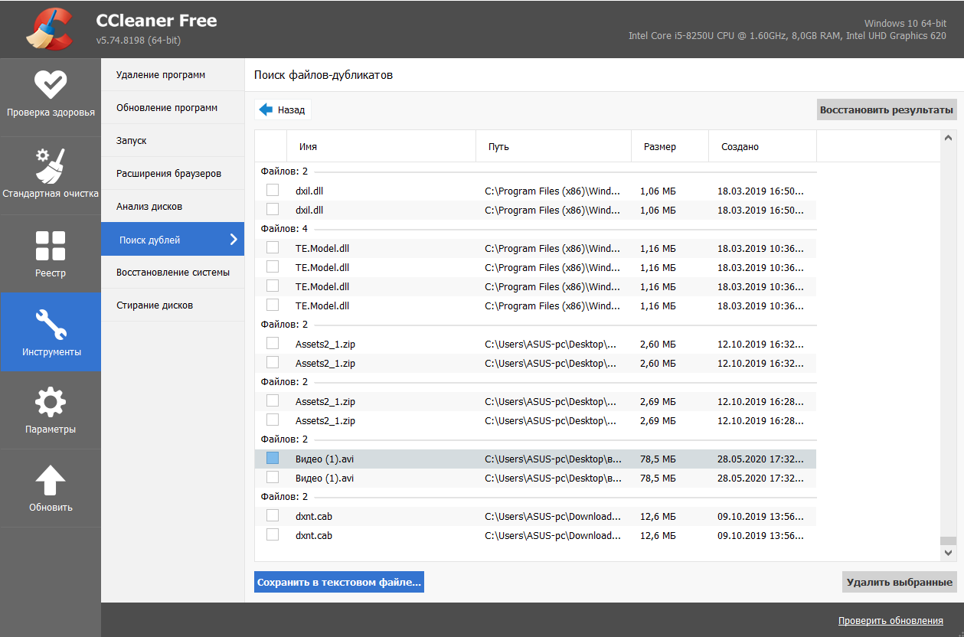

Задание №4

